IMAGE AND VIDEO PROCESSING
6. Digital Video Processing
6.1 Introduction to Digital Video Processing, Sampled Video.
6.2 Composite and Component Video, Digital video formats and applications.
PAST QUESTIONS:
- Explain any five video file formats.
- Digital video processing.
NOTES:

*Digital Video Processing :-
Digital Video Processing is a branch of signal processing that deals with the representation, manipulation, and analysis of video signals in a digital format. It involves a combination of image processing techniques applied to a sequence of images (frames) to enhance, compress, or analyze video content.
Digital Video Processing refers to techniques used to analyze, manipulate, and enhance video signals in digital form. It is a branch of image processing where instead of working with still images, we deal with sequences of images (frames) over time — essentially, videos.
Key operations –
- Frame extraction - Breaking the video into individual frames for analysis or processing.
- Noise reduction - Removing visual noise across frames.
- Video compression - Reducing video size using codecs.
- Video enhancement - Adjusting brightness, contrast, sharpness, or stabilizing shaky videos.
Applications –
- Multimedia and Streaming (YouTube, Netflix)
- Video Surveillance and Security
- Medical Imaging (Endoscopy, motion tracking)
- Robotics and Computer Vision
- Augmented Reality / Virtual Reality
- Traffic Monitoring and Smart Vehicles

*Composite vs Component Video :-
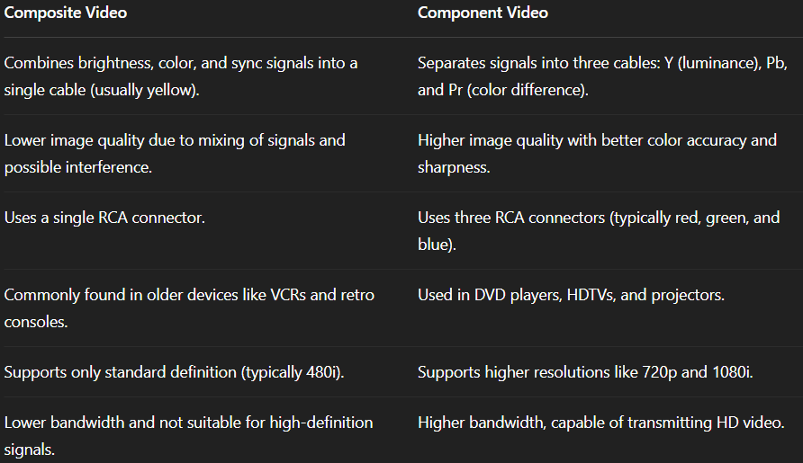

*Digital Video Formats :-
Video file formats are essential for storing, compressing, and transmitting digital video. They consist of a container format (which holds video, audio, subtitles, and metadata) and a codec (which compresses and decompresses the video data).
- MP4 - MP4 is one of the most widely used video formats, designed for high compatibility across devices and platforms.
Key features –
- Supports video, audio, subtitles and metadata.
- Highly compressed but retains good quality.
- Works with streaming services, mobile devices, and web applications.
- Used in YouTube, social media, and online courses.
Common use – Online streaming, general video sharing.
- AVI – Audio Video Interleave (AVI), developed by Microsoft, is an older but still widely supported video format that provides high-quality video storage. However, it results in large file sizes due to minimal compression.
Key features –
- Supports multiple codecs.
- Offers high-quality video playback.
- Can contain lossless or lossy video compression.
Common use – Video editing and production, storing high quality video content.
- MKV – Matroska Video Format (MKV), MKV is an open-source, flexible container format that can store high-quality video with multiple audio and subtitle tracks.
Key feature –
- Supports multiple video, audio, and subtitle tracks in one file.
- Excellent for high-definition video storage.
Common use - HD video storage, Movies with multiple language tracks and subtitles, archiving and long-term storage of high-quality video.
- MOV – Apple QuickTime Movie Format (MOV), developed by Apple, is commonly used for high-quality video playback and editing. It is the native format for MacOS and iOS.
Key features –
- Designed for professional video editing (Final Cut Pro, iMovie).
- Supports high-resolution video and lossless codecs like ProRes.
- Compatible with Windows and MacOS but optimized for Apple devices.
- Can result in large file sizes compared to MP4.
Common use – Professional video editing, Mac based multimedia applications, High-quality movie storage.
- FLV – Flash Video Format (FLV), FLV was a popular format used by Adobe Flash Player for web-based video streaming. While Flash is no longer widely used, FLV videos are still found on some platforms.
Key features –
- Optimized for online streaming.
- Works well with low-bandwidth connections.
- Primarily used with older Flash-based web applications.
Common use – Older online streaming platforms, legacy web-bases video applications

